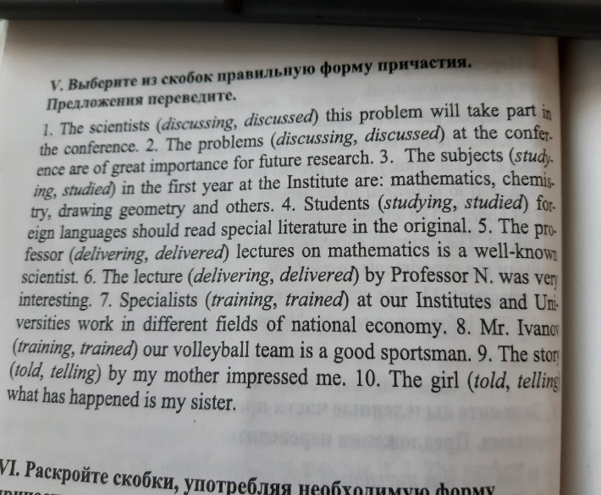

1. discussing
2. discussed
3. studied
4. studying
5. delivering
6. delivered
7. training
8. trained
9. told
10. telling